Post Lab Questions and Tables of Lab 4:
1. Why is the voltage across each resistor in a parallel circuit the same?
In a parallel circuit, all resistors are connected directly across the same two points of the power supply. Because of this, the potential difference (voltage) across each branch is equal to the source voltage.
So, every resistor gets the same voltage, regardless of its resistance value.
2. When parallel resistors are of different values, which has the greatest power loss?
Power dissipated in a resistor is given by the formula:
$$P= \frac{V^{2}}{R}$$
Since voltage is the same across all resistors in parallel, power depends inversely on resistance.
Therefore, the resistor with the smallest resistance will have the greatest power loss.
3. How does the current across any branch of a parallel circuit vary?
The current in each branch depends on the resistance of that branch, according to Ohm’s Law:
$$V=IR$$
This means:
Lower resistance → Higher current
Higher resistance → Lower current
So, current divides among branches inversely proportional to their resistance.
4. What happens to total resistance if one parallel resistor is removed (open circuit)?
When one resistor is removed:
The number of parallel paths decreases
Less current can flow overall
As a result, the total (equivalent) resistance increases.

Tables:
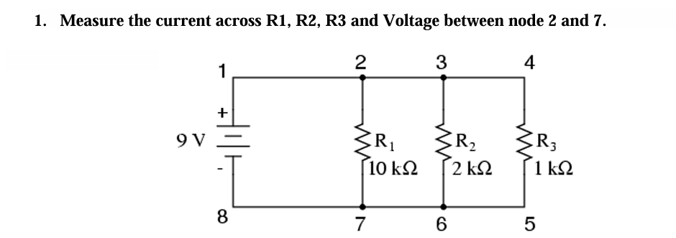

Practical Values:
R1 Current | R2 Current | R3 Current | Voltage
0.9mA | 4.5mA | 9mA | 9V

Theoretical Values:
R1 Current | R2 Current | R3 Current | Voltage
0.9mA | 4.5mA | 9mA | 9V

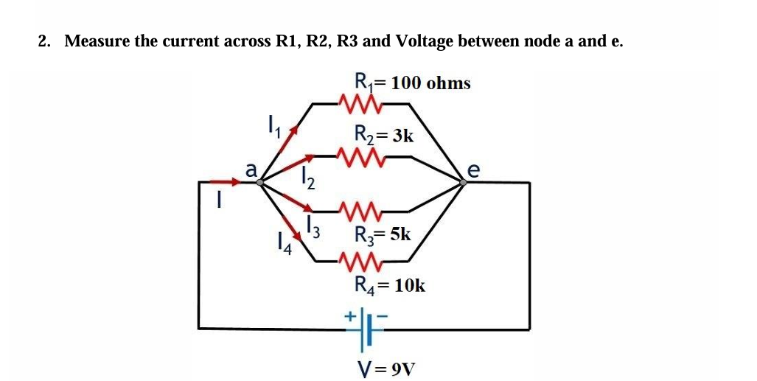
Practical Values:
R1 Current | R2 Current | R3 Current | R4 Current | Voltage
90mA | 3mA | 1.8mA | 0.9mA | 9V

Theoretical Values:
R1 Current | R2 Current | R3 Current | R4 Current | Voltage
90mA | 3mA | 1.8mA | 0.9mA | 9V

